**Assignment 18.2**

Travel data analysis

Travel Sector Dataset Description: Column 1: City pair (Combination of from and to): String Column 2: From location: String Column 3: To Location: String Column 4: Product type: Integer (1=Air, 2=Car, 3 =Air+Car, 4 =Hotel, 5=Air+Hotel, 6=Hotel +Car, 7 =Air+Hotel+Car) Column 5: Adults traveling: Integer Column 6: Seniors traveling: Integer Column 7: Children traveling: Integer Column 8: Youth traveling: Integer Column 9: Infant traveling: Integer Column 10: Date of travel: String Column 11: Time of travel: String Column 12: Date of Return: String Column 13: Time of Return: String Column 14: Price of booking: Float Column 15: Hotel name: String

1: Find out the top 10 destination people travel the most: Based on the given data, we can find the most popular destination that people travel frequently. There are many destinations out of which we will find only first 20, based on trips booked for particular destinations.

2: Find out the top 10 cities that generate high airline revenues for travel, so that the site can concentrate on offering discount on booking, to those cities to attract more bookings.

Note: Implement Top-k design patterns in mapreduce for solving the problem statements. For reference you can follow this blog

**Driver**

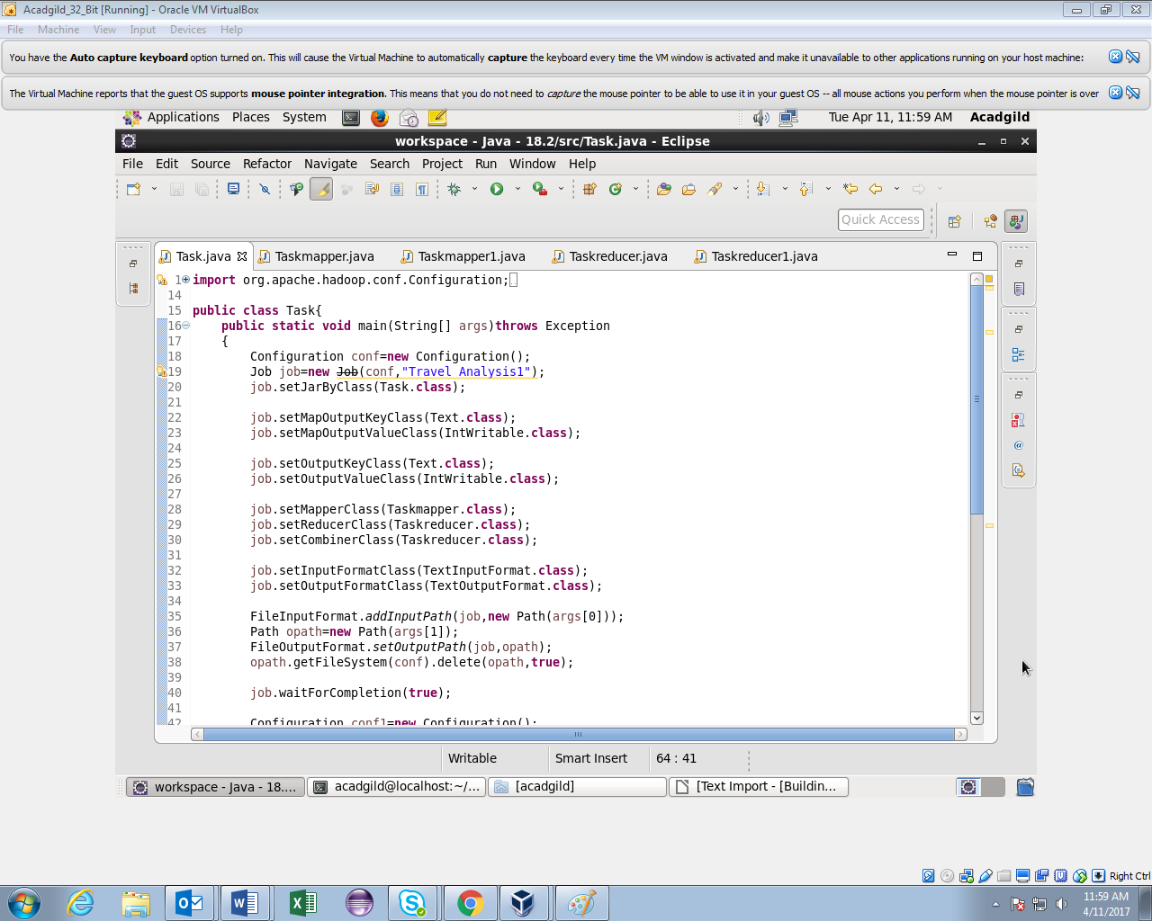

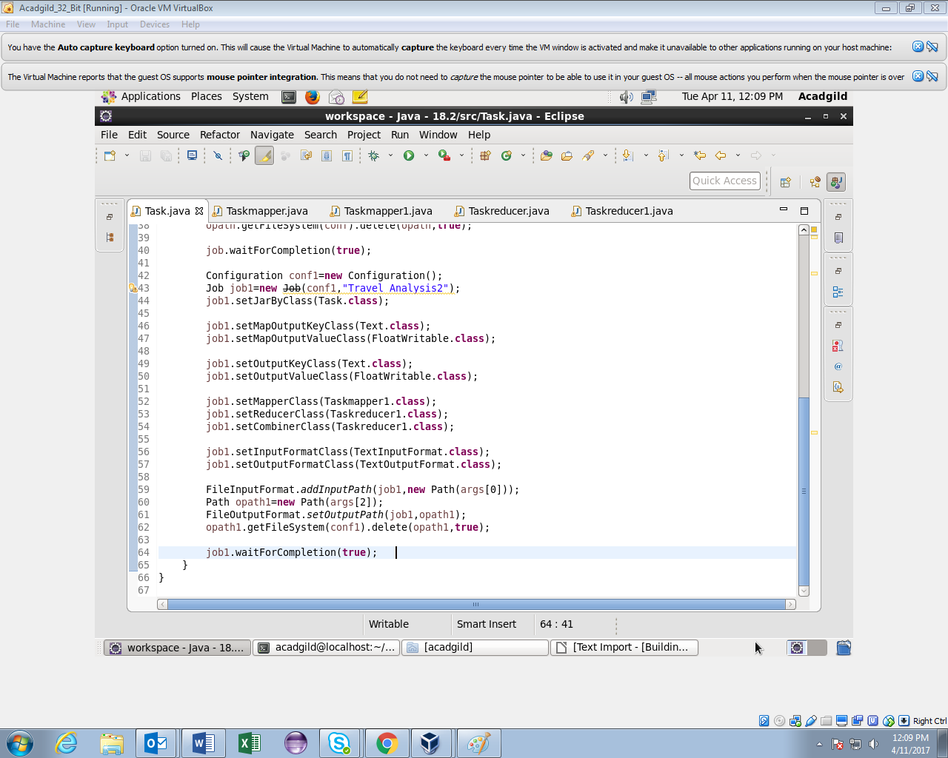

**Mapper1**

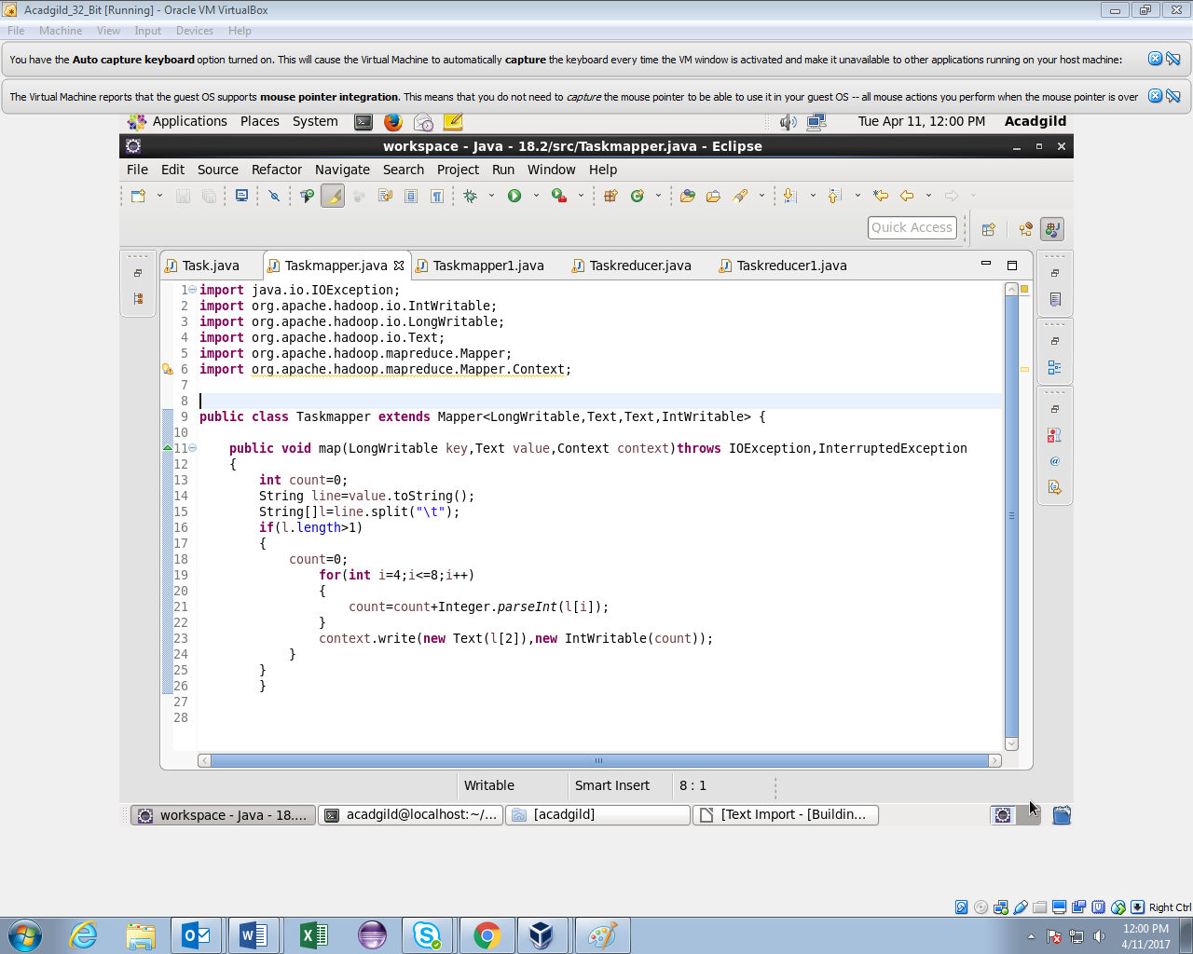

**Reducer1**

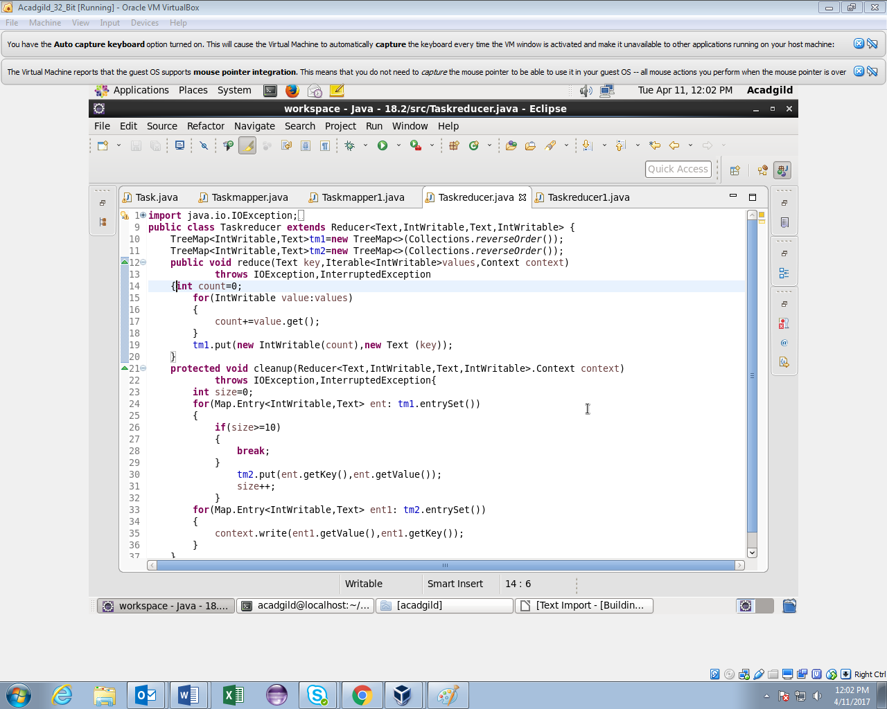

**Mapper2**

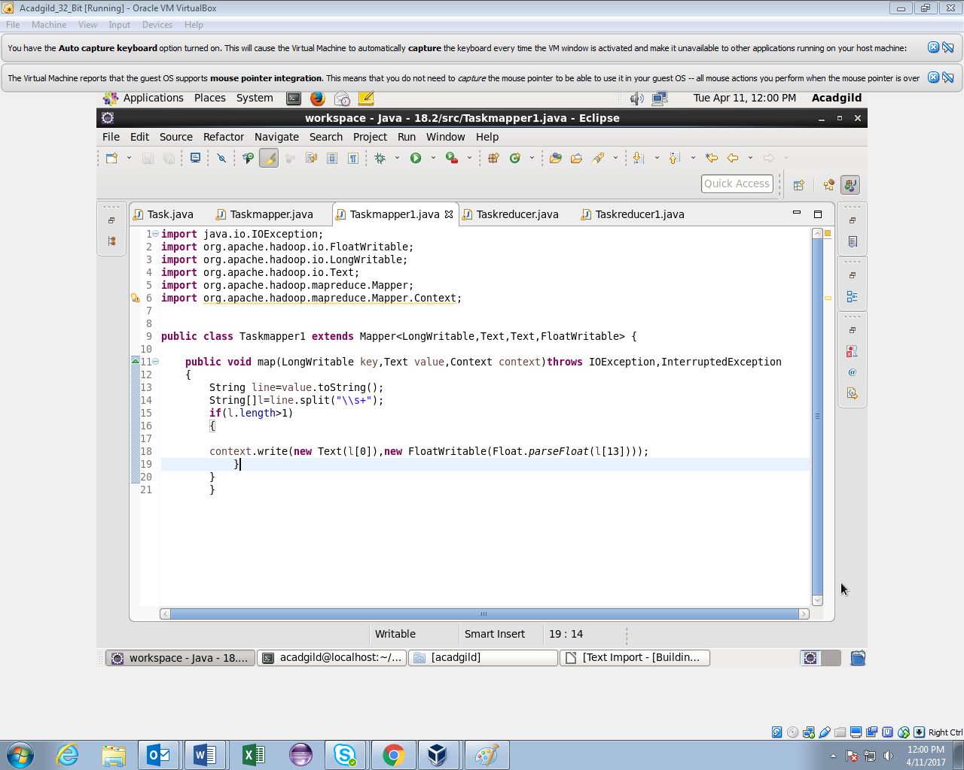

**Reducer2**



**Running Jar**

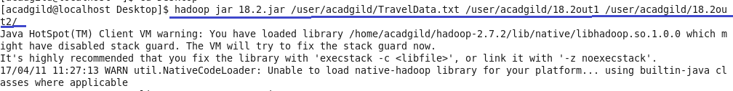

**Output for Task1**



**Output for Task2**

